**Research paper**

**Machine learning**

**Akhmedova Shakhnoza (Noza)**

**Introduction**

Gender is one of the main factors in the interaction between individuals. Recently, computer-driven image recognition systems that automatically recognize and classify human subjects have become increasingly widespread. In other words, with the development of social media environments and smartphones, gender recognition applications have both begun to grow and become important. In many fields such as face recognition, facial expression analysis, tracking and surveillance, human-computer interaction, biometry, gender recognition applications can be seen. A form of machine intelligence called deep learning is the basis of these image recognition systems, as well as many other artificial intelligence efforts.

**Matter of subject**

Being born as a Muslim woman, wearing a veil or head covering called as ‘hijab’ acts as a show of obedience to our Islamic holy book “the Qur’an” and to God “Allah”, as well as being a symbol of modesty and a constant reminder to hold fast to Islamic beliefs such as being honest and generous to those in need. The hijab, or headscarf, is a piece of clothing Muslim women wear to cover themselves when they are outside or in the presence of males who are not part of their immediate family. This means that hijab is not obligatory in front of the father, husband, female friends, brothers, grandfathers, uncles or young children. As being from Islamic family and having a strong believer in Islam, having a headscarf is considered to be one of the most important Islamic practices and it is obligatory to have a headscarf in the presence of opposite gender— it deals with a range of attire and conduct. In addition, having a headscarf and covering the body completely serves as a protective shield. All women were created beautiful and Islam encourages women to conceal their beauty and protect themselves from being sexualized or objectified and misrepresented. The hijab protects the woman from being judged by the way she looks and allows her to be respected and honoured for who she is. It allows the woman to shine through with her wonderful character, personality, intellect and skill set, irrespective of what she looks like or how good her body appears.

There is the evidence from Qur’anic verse:

“وَقُل لِّلْمُؤْمِنَاتِ يَغْضُضْنَ مِنْ أَبْصَارِهِنَّ وَيَحْفَظْنَ فُرُوجَهُنَّ وَلَا يُبْدِينَ زِينَتَهُنَّ إِلَّا مَا ظَهَرَ مِنْهَا ۖ وَلْيَضْرِبْنَ بِخُمُرِهِنَّ عَلَىٰ جُيُوبِهِنَّ ۖ وَلَا يُبْدِينَ زِينَتَهُنَّ”

Translation: “And tell the believing women to reduce [some] of their vision and guard their private parts and not expose their adornment except that which [necessarily] appears thereof and to wrap [a portion of] their headcovers over their chests and not expose their adornment….” (Quran 24:31)

When Muslims obey God’s commands, they are rewarded and earn His eternal pleasure. Hence, Muslim women wear the headscarf as an act of love and obedience towards their Creator, she is rewarded for her sacrifice and obedience to her Lord.

Even though the hijab is indeed a woman’s obligation in Islam, it is *not* a *pillar of Islam*,” one of the [five core tenets](http://www.bbc.co.uk/religion/religions/islam/practices/fivepillars.shtml) of the religion such as faith, prayer, charity, fasting and pilgrimage to Mecca. Thus, it is still possible to meet non-scarf women that are considered to be practicing Muslims as well.

Being born in Islamic family and carrying Islamic values, it has always been my pride to value my religion by wearing a headscarf and observing dressing etiquette and religious norms. However, I have always been facing issues whenever some guests would knock on the door because based whether the person is a female or male I would put my headscarf on. In other words, It is obligatory for me to put on a headscarf on my head in case a person knocking on the door is a male but I don’t have to wear a headscarf when the person knocking on the door is a female. It made me think that I could come up with the idea of implementing a gender recognition out of male and female images with deep learning to solve that inconvenience on daily basis of my life.

**The methodology**

An image classification utilizing keras would be conducted which includes generating a dataset for testing, visualizing data being trained along with preprocessing data and finally training the model using epochs. I would like to see the accuracy of prediction of my model on the testing dataset which would test the accuracy of prediction of the model.

**The dataset creation**

I would come up with the creation of my own image data set by using websites which have jpeg files (.jpg) images to download and generate a folder to test the accuracy of my model. Due to the fact that we have to have a lot of images to train the model, I am going to be working with large dataset of celebrities extracted from the following website:

**Resources for the dataset to just filter out “GENDER” images:**

<https://analyticsindiamag.com/10-face-datasets-to-start-facial-recognition-projects/>

<http://mmlab.ie.cuhk.edu.hk/projects/CelebA.html>

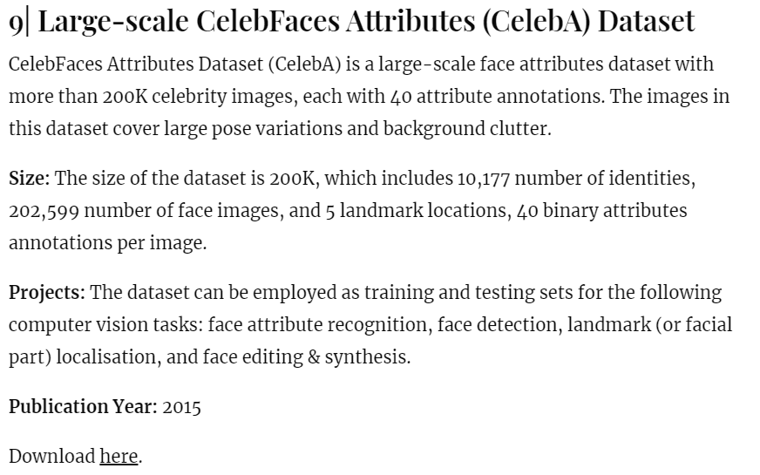

In this study, the Convolutional Neural Networks (CNN) will be used as the deep learning methods. Deep learning systems are often “trained” to perform these tasks by being presented with many examples of pictures, objects or scenarios that humans have already labeled “correct” or “incorrect” or in our case as “male” or “female”. These labeled examples that help the system learn are called “training data,” and they play a major role in determining the overall accuracy of these systems. Since I wanted to see how the choice of training data impacted the overall accuracy of our models, so I searched online for different collections of images of human faces. Experiments will be performed on a face data set generated for gender recognition that includes thousands of male and female images to train. It would also include a provision to have a URL to check images from the internet and to determine whether it is a female or male. Keras would be used to load the image and then the image would be converted into an array. After which we would use the predict function to give us the probability of the image that has been loaded as being a man or a woman.

In addition, I would like to use image data augmentation to practice to artificially introduce sample diversity by applying random yet realistic transformations to the training images, such as random horizontal flipping or small random rotations. This helps expose the model to different aspects of the training data while slowing down overfitting. I start the model with the data_augmentation preprocessor, followed by a Rescaling layer. I include a Dropout layer before the final classification layer. I am planning on testing validation accuracy after training for 50 epochs on the full dataset.

## Convolutional Neural Network (CNN) MATH

## The convolutional neural network can be broken down into two parts:

* The convolution layers: Extracts features from the input
* The fully connected (dense) layers: Uses data from convolution layer to generate output

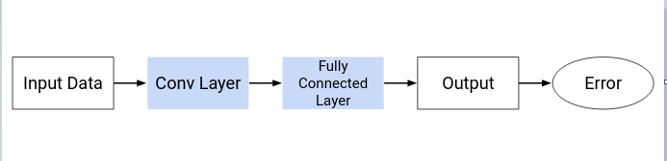

As we discussed in the previous section, there are two important processes involved in the training of any neural network:

1. **Forward Propagation:** Receive input data, process the information, and generate output
2. **Backward Propagation:** Calculate error and update the parameters of the network

If I am asked to identify objects in two given images, I would typically go with observing the image, trying to identify different features, shapes and edges from the image. This is precisely what the hidden layers in a [CNN](https://courses.analyticsvidhya.com/courses/convolutional-neural-networks-cnn-from-scratch?utm_source=blog&utm_medium=mathematics-behind-convolutional-neural-network) do – find features in the image **by** looking at images and identify the object’s shape and edges. A CNN does this by comparing the pixel values. Convolution is often represented mathematically with an asterisk * sign. If we have an input image represented as X and a filter represented with *f*, then the expression would be:

Z = X * *f*

### Forward Propagation Summary

**Step 1:** Load the input images in a variable (say X)

**Step 2:** Define (randomly initialize) a filter matrix. Images are convolved with the filter

Z1 = X * f

**Step 3:** Apply the Sigmoid activation function on the result

A = sigmoid(Z1)

**Step 4:** Define (randomly initialize) weight and bias matrix. Apply linear transformation on the values

Z2 = WT.A + b

**Step 5:** Apply the Sigmoid function on the data. This will be the final output

O = sigmoid(Z2)

[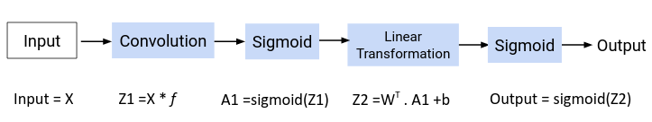](https://cdn.analyticsvidhya.com/wp-content/uploads/2020/02/Screenshot-from-2020-02-03-21-30-16.png)

Now the question is – how are the values in the filter decided? The CNN model treats these values as parameters, which are randomly initialized and learned during the training process. We will answer this in the next section.

Here is a generic equation for updating the parameter values:

*new_parameter = old_parameter - (learning_rate * gradient_of_parameter)*

The learning rate is a constant that controls the amount of change being made to the old value. The slope or the gradient determine the direction of the new values, that is, should the values be increased or decreased. So, we need to find the gradients, that is, change in error with respect to the parameters in order to update the parameter values.

**Challenges**

Proposed methodology can be improved further to gain higher accuracy in classification. If I am going to implement the same model to Clark life or a store operation, it would help them with better video surveillance systems in the case of thievery, stealing, shoplifting or kidnapping. From my perspective, adding more parameters to the model such as age, height, color of clothes would be useful to represent the geometric variation of gender to our classifier in order to increase the performance of our model. Reducing the gap between age ranges would result with a better classification of images in to several age groups to enhance the measurement of success.

To be more precise, Automatic classification of facial images into gender has been used in several applications in the commercial world such as video surveillance systems and enhance image searching in search engines. The proposed methodology used parameters taken from the geometric facial feature variations influenced by the two gender types. These parameters are then used to classify the images into corresponding gender and other parameters by using a neural network.

**Conclusion**

This paper introduced an approach to classify facial images into their corresponding gender. The main emphasis of this research is to apply the training and learning process of the human brain in pattern recognition and classification from the normal computer. Proposed algorithm can be enhanced to perform accurately under any condition of images in the future.

**References**

August, S., 2020. *The Challenges Of Using Machine Learning To Identify Gender In Images*. [online] Pew Research Center: Internet, Science & Tech. Available at: <https://www.pewresearch.org/internet/2019/09/05/the-challenges-of-using-machine-learning-to-identify-gender-in-images/> [Accessed 23 October 2020].

(CNNs), D., 2020. *Introduction To Neural Network| Convolutional Neural Network*. [online] Analytics Vidhya. Available at: <https://www.analyticsvidhya.com/blog/2020/02/mathematics-behind-convolutional-neural-network/> [Accessed 23 October 2020].

Skalski, P., 2019. *Gentle Dive Into Math Behind Convolutional Neural Networks*. [online] Medium. Available at: <https://towardsdatascience.com/gentle-dive-into-math-behind-convolutional-neural-networks-79a07dd44cf9> [Accessed 23 October 2020].

Santiago Teles de Menezes, Rafael Marrocos Magalhaes, R. and Maia, H., 2018. *Object Recognition Using Convolutional Neural Networks*. [ebook] Available at: <https://www.researchgate.net/publication/331850803_Object_Detection_Using_Convolutional_Neural_Networks> [Accessed 23 October 2020].

[**https://github.com/arunponnusamy/gender-detection-keras/blob/master/detect_gender.py**](https://github.com/arunponnusamy/gender-detection-keras/blob/master/detect_gender.py)

[**https://github.com/arunponnusamy/gender-detection-keras/blob/master/detect_gender_webcam.py**](https://github.com/arunponnusamy/gender-detection-keras/blob/master/detect_gender_webcam.py)

**https://github.com/arunponnusamy/gender-detection-keras/blob/master/train.py**